Kateri Circles Vol. 5 Issue 1
January Signpost

for the

St. Tekakwitha Opening prayer:

God of all nations and peoples. You have filled Your Creation with
Your mighty presence. Through Your handiwork You speak to our heard words that satisfy our every de- sire.
You called Your servant the Mohawk maiden Saint Kateri Tekakwitha to embrace the Gospel of your Son Jesus Christ to do Your will and to serve
others with the gifts You gave her.
May she who held tight to the cross of Your Son through her short life marred by sickness suffer- ing and persecution, be our intercessor during our own trials. May her embrace of the Catholic faith and her openness to sharing Jesus with others inspire us
to be new evangelizers to all cultures and peoples.

GOOD RED ROAD

Winter North Black
Sin

Hopelessness- Despair
Fruits of the Holy Spirit Joy/ Gentleness Redemptive suffering
Gifts of the Holy Spirit
Fortitude Fear of the Lord

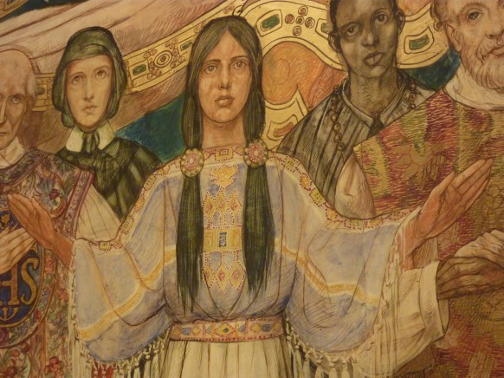

Who do we need to bring in the circle? Who do we need to pray for:
Family members who are sick. Family members who have died. Struggles that we are facing?
Let us bring our joys and sufferings onto this circle.

Holy Matrimony
The Sacrament of Holy Matrimony is for a man and a woman to live out their lives as husband and wife in love, compassion and respect. The Sacrament also is for the fostering of children in a loving environment. Because the intention is to have a lifelong partnered , loving and shared life, the Church puts a number of requirements for the Marriage Sacrament that need to be met at the time when the wedding takes place.
The key element of the Marriage Sacrament is the vows that the groom and bride say to each other. Their promises of love is so important that the Church makes sure that these promises are freely given to each other. Both the man and the women needs to be free from coercion, impediments and be able to fully understand the promised commitment of love, that is, the love commitment to Christ and each other.
This Covenant is about love but is it also about responsibility. The promise of looking after, caring for and thinking about the other before yourself is the bases of the covenantal relationship between a wife and husband.
In Greek, there are three words for love. All meaning different things. There is philos love such as the love for our neighbor, eros love, what we refer to as romantic love and there is agape love, the love that a man and a women share together after a long and happy marriage. What Christ and the Church strives for is agape love. Agape love is the deepest love, the love of shared experiences, deep commitment and an enduring compassionate partnership. It is one of the sincerest way that Christ loves us and how he wants us to love him. It is also the center of the marriage covenant.
The last aspect of marriage is the concept of the “House Church.” When a man and a women get married, they become an instant family. When they have children, their family grows. Parents are the first educators in faith for their children. That means that they have a little church as an aspect of their family. Their home is a place where Christ is worshipped as a family. It is only when all of the small church families are grounded in faith that the larger parish family can succeed.

What does the Sacrament of Holy Matrimony
Mean to Catholic Native Communities?

An important fundamental element of marriage is that of the family. One aspect of many Native cultures is the belief in the importance of the family, including the extended family. This cultural aspect is one of the important aspects that has helped Native communities to survive the constant challenges that they have faced. However there has been many forces at work that have been a direct threat to this cultural aspect of being family centered. Sometimes, the larger U.S. culture does not seem to put a higher value on the family. The problem is when some Native communities adopt this wider U.S. culture and devalue this important virtue of what is a family. With all of the challenges with many Native communities, the resilience, compassion and solidness of the family has weathered many hardships and storms.

The other aspect of the importance of marriage is the unity of both faith and culture. Through the Wedding Sacrament, cultural elements are often brought in that help emphasize the spiritual nature of what a wedding and marriage is. For thousands of years, Native communities have expressed the sacredness of a man and a women professing their love together. The Church has used those cultural elements in a sacramental form. The liturgical documents enshrine that the Marriage Sacrament reflect what is in culture that is holy and significant.

Because the family is crucial to the health, happiness and stability of Native communities, the Church along with tribal and other government agencies has a vested interest to insure the central role of a long-term commitment of love between a wife and husband. The advocacy of this social dimension of marriage is an important focus of the Church. The endurance of marriage and the family is not only an important virtue for faith, but is also an important way to combat poverty, racism, powerlessness and many other social evils.

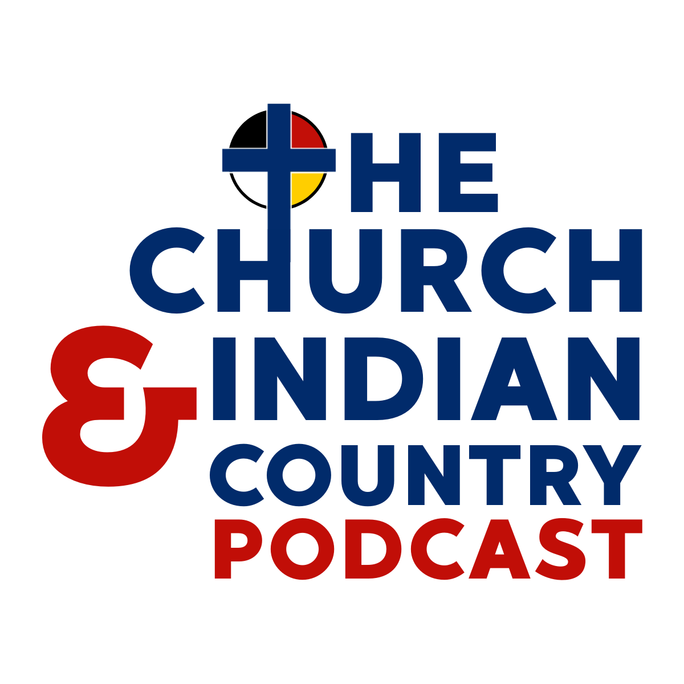

Eucharistic Revival

- What steps is my (Arch)Diocese taking to be part of the Eucharist Revival?

- How can I encourage the Native communities to get involved in the Eucharist Revival?

- What are the ways I can encourage my parish community to hance the devotion to the Eucharist?

- What are the resources that I can use to promote the Eucharistic Revival?

- How can I make certain Catholic Natives are represented at all levels of the Eucharistic Revival?

- How are the stories from the La Florida Martyrs relevant for the Eucharistic Revival?

- How can I use their stories to better inform my parish, my community and my diocese about the importance of the Eucharist?

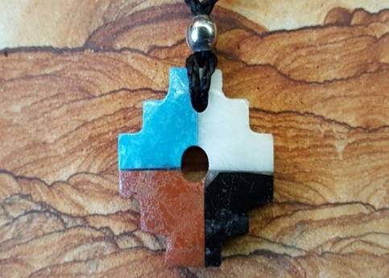

Closing prayer from the Black and Indian Mission Office:
God of all nations and peoples. You have filled your creation with Your mighty presence. Through Your handiwork You speak to our hearts words that satisfy our every desire.
You called Your servant, the Mohawk maiden Saint Kateri Tekakwitha to
embrace the Gospel of your Son Jesus Christ, to do Your will and to serve others with the gifts You gave her.
May she who held tight to the cross of Your Son throughout her short life marked by sickness, suffering, and persecution, be our intercessor during our own trials. May her embrace of the Catholic faith and her openness to sharing Jesus
with others inspire us to be new evangelizers to all cultures and peoples. May she who sought our Jesus in the Blessed Sacrament lead up to similar reverences for
the Eucharist so that, like Saint Kateri, our last words may be, “Jesus, I love You.” Amen.

Although this was composed by Rev. Michael Carson, the USCCB and the Subcommittee on Native Americans is not responsible for the content. You may use any or all of the “Sign Post” for the benefit of the Tekakwitha's Circles. This is only a suggested guide. Use what you find useful. Each
addition has been reviewed by the Tekakwitha Executive Board. If you have any feedback on how the “Signposts” can be improved, I would love to hear from you at
mcarson@usccb.org
The Tekakwitha Conference holds the copyright
Rev. Mike Carson

